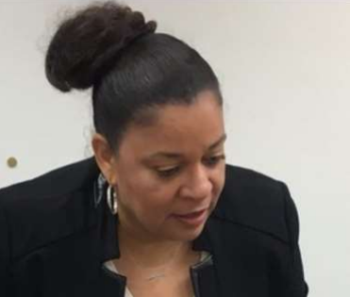
Mrs. Brandi Beavers

Hello Everyone, my name is Mrs. Beavers and I serve the students, faculty and parents of DeKalb County School District Region 2 High Schools as a Post-Secondary Transition Specialist.

Resource Page: https://tinyurl.com/Post-SecondaryPlanning

Before I cover some of my duties, I want to start by sharing with you how much I absolutely adore my position within DCSD. My umbrella of duties is - anything that help students transition from high school to their college/gap year/career choice after high school.

Below are some of my responsibilities within Region 2 as a PSTS:

- Coordinating college/career fairs within my region and district wide
- Helping students with their college applications/FAFSA completion, scholarship searches or any paperwork needed for college or career such as a resume or Common App
- Assisting Counselors/APs/Teachers/Principals with college and career readiness indexes
- Training/Assisting everyone within my region with Naviance (students, parents, counselors, and school staff members)
- Attending Professional Development Sessions to remain up-to-date in new college and career practices
- Sending Transcripts - Naviance
- Presentations (FAFSA night or grade level nights) college and career information
- Assisting parents and students with their GAfutures accounts
- Identifying and meeting with students who may need extra help with their college and career choices
- Being available and flexible to help whenever needed within your region
- Identifying factors impacting academic success
- And so much more... (that prepares students for college and career)

Contact Brandi Beavers at Brandi_Beavers@dekalbschoolsga.org

